PROJECT DEMONSTRATION

DEMO LINK:
https://drive.google.com/file/d/1g_EqPqQqrLUgEjlEYGDzSNEL5NHX_5Y4/view?usp=drivesdk

DEMONSTRATION STEPS

Step 1: Login to ServiceNow Instance
The first step in the demonstration process is logging into the ServiceNow platform. The administrator opens the ServiceNow instance in a web browser such as Google Chrome or Microsoft Edge.
Using valid login credentials, the administrator accesses the ServiceNow dashboard. The dashboard provides access to various modules such as Incident Management, Import Sets, and System Configuration.
Once logged in, the administrator can begin demonstrating the implemented features of the project.

Step 2: Import Employee Data Using Import Sets
The next step is to demonstrate how employee data is imported into ServiceNow. The administrator navigates to the Import Sets module and selects the option Load Data under System Import Sets.
The employee data file created earlier in Excel or Google Sheets is uploaded into the system. This file contains fields such as Name, Email, Department Manager, and Manager Email.
After uploading the file, ServiceNow creates an import set table and stores the uploaded data in it. The administrator can open the table and verify that the employee records have been successfully imported into the staging table.
This step demonstrates how ServiceNow allows administrators to import large amounts of external data efficiently.

Step 3: Create and Configure Transform Map
After the employee data is imported, the next step is to create a Transform Map. The transform map is used to move data from the import set table into the target table.
The administrator navigates to the Transform Maps module and creates a new transform map. The source table is selected as the import set table, and the target table is selected as the User table in ServiceNow.
Field mapping is then performed to ensure that the fields from the import set table correspond to the correct fields in the user table. ServiceNow provides the Auto Mapping feature to match similar field names automatically.
If necessary, the administrator can manually map additional fields using the Mapping Assist tool.

Step 4: Transform the Data
Once the transform map is configured, the administrator performs the transform operation. During this process, ServiceNow reads the records from the import set table and inserts them into the user table based on the defined mappings.
After the transformation process is completed, the administrator verifies that the employee records have been successfully created in the system.
This confirms that the data import and transformation process is working correctly.

Step 5: Configure Dot Walking in Incident Form
The next part of the demonstration shows how dot walking is used to display related information on the Incident form.
The administrator navigates to the Incident module and opens the Incident form configuration. In the form layout section, additional fields are added using dot walking.
For example, the following fields are added:
- Assigned To → Department
- Assigned To → Email
- Assigned To → Manager
These fields retrieve information directly from the assigned user record. Once the form layout is saved, the Incident form will automatically display this information when an employee is selected in the Assigned To field.
This feature allows users to access important employee details without opening the employee record separately.

Step 6: Configure Dictionary Override for Priority
Another important step in the demonstration is configuring dictionary override to modify the default priority value for incidents.
The administrator opens the dictionary entry for the Priority field and creates a dictionary override for the Incident table.
The option to override the default value is selected, and the default priority value is changed to Moderate (3).
After saving the configuration, all newly created incidents will automatically have this priority value by default.
This step demonstrates how field behavior can be customized for specific tables without affecting the parent table configuration.

Step 7: Create and Test an Incident Record
To verify that all configurations are working correctly, the administrator creates a new incident record.
During the incident creation process, the administrator fills in the mandatory fields such as short description and category. An employee from the imported user records is selected in the Assigned To field.
Once the employee is selected, the system automatically displays the department, email, and manager information using dot walking.
The administrator also verifies that the Priority field is automatically set to Moderate (3) as configured through dictionary override.
If all these features work as expected, the system implementation is considered successful.

RESULT
The demonstration confirms that the project has been successfully implemented in the ServiceNow platform.
Employee data can be imported automatically from external files using Import Sets and Transform Maps. The Incident form displays related employee information such as department and manager details using dot walking. Additionally, the priority field for incidents has been customized using dictionary override.
These features work together to improve the efficiency of incident management and provide quick access to important information.
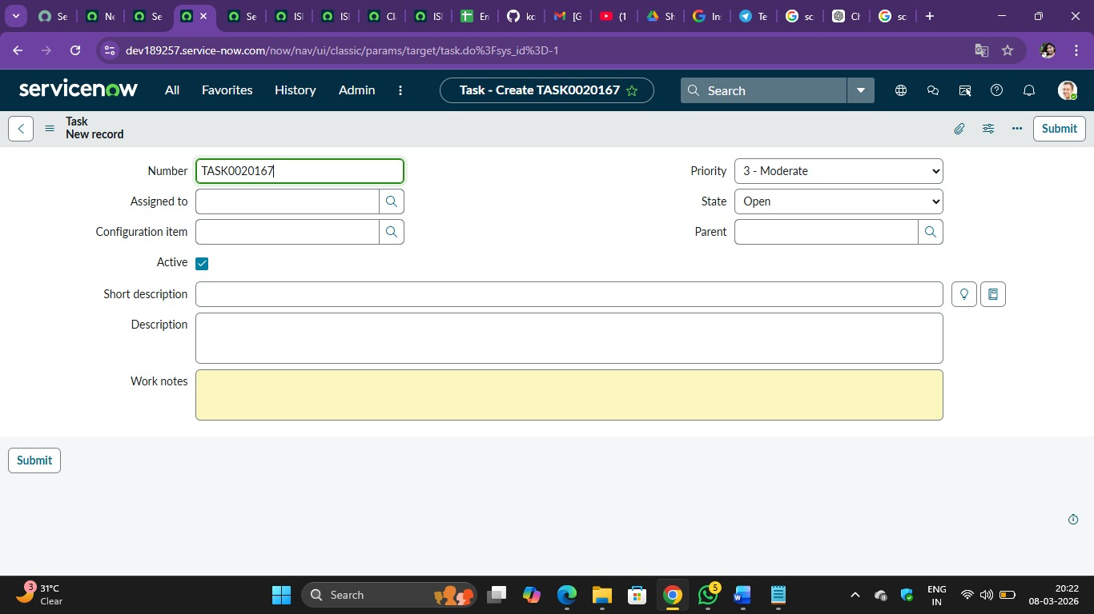

CONCLUSION
The project demonstration clearly shows how ServiceNow features can be used to automate data management and improve incident handling processes.
By importing employee data automatically, displaying related information in the incident form, and customizing priority settings, the system reduces manual work and improves productivity.
This implementation helps organizations manage incidents more effectively and ensures that critical issues receive the attention they require.

